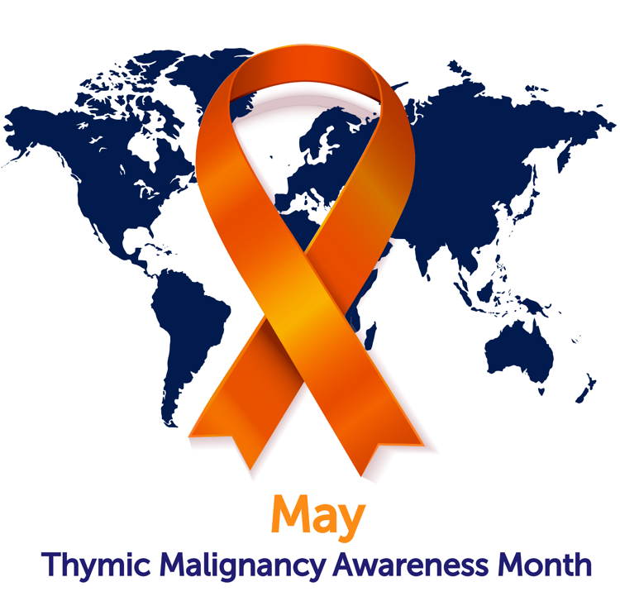

**How are they found?**

Almost one-third of all thymic cancer patients have no noticeable symptoms when they are diagnosed. The thymic cancer is found by accident while doctors are looking for other things. Symptoms include:

* **Pain in the chest**
* **Difficulty with breathing**
* **Long standing cough**
* **Weakness in the muscles**

If you have any of these symptoms, your doctor may perform a chest CT (computed tomography) and/or MRI (magnetic resonance imaging) scan. A radiologist will analyze the scans searching for the tumor and will assess if it invades any structures. You might also be given a PET (positron emission tomography) scan that may be able to detect metastases (secondary tumors) in other organs.

**Thymic Epithelial Tumors…**

**…are very rare malignant neoplasms originating from the thymus, a small organ in the upper part of the chest behind the sternum, normally responsible for appropriate function of the immune system.**

**There are three types of thymic epithelial tumors, and the terminology often gets confused between them:**

Thymomas

Thymomas are typically slow growing tumors that more or less resemble a normal thymus. Despite their usual favorable outcome, thymomas are malignant tumors as they can metastasize and/or recur. People diagnosed with thymoma often have other diseases of the immune system, most commonly **myasthenia gravis**, a disease in which the muscles become weak.

Thymic Carcinomas

In thymic carcinomas, the cells no longer look like normal thymic cells. Thymic carcinomas grow more quickly than thymomas and often have spread to other parts of the body when the cancer is found.

**Thymic Neuroendocrine Tumors**

Thymic neuroendocrine tumors are even less common than thymomas and thymic carcinomas. These tumors are also malignant.

Thymic Malignancy Awareness Month

MAY

**Have you been diagnosed**

**with a thymic tumor?**

**This information is for you!**

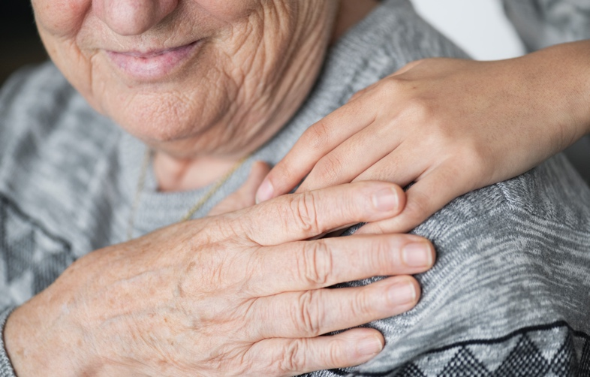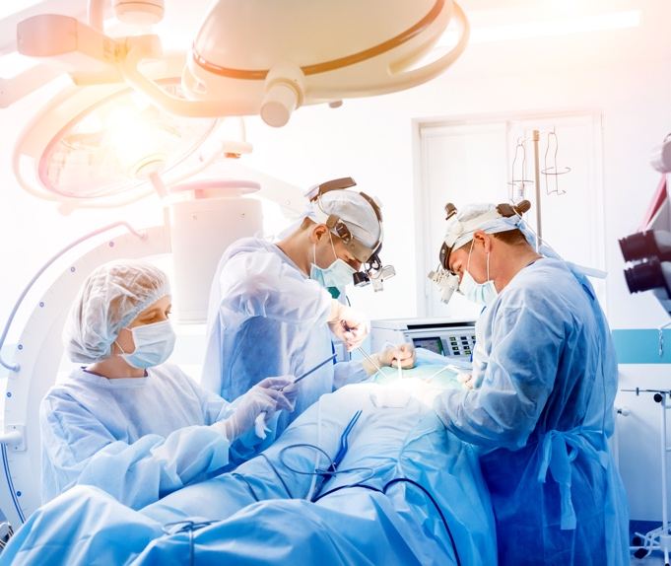[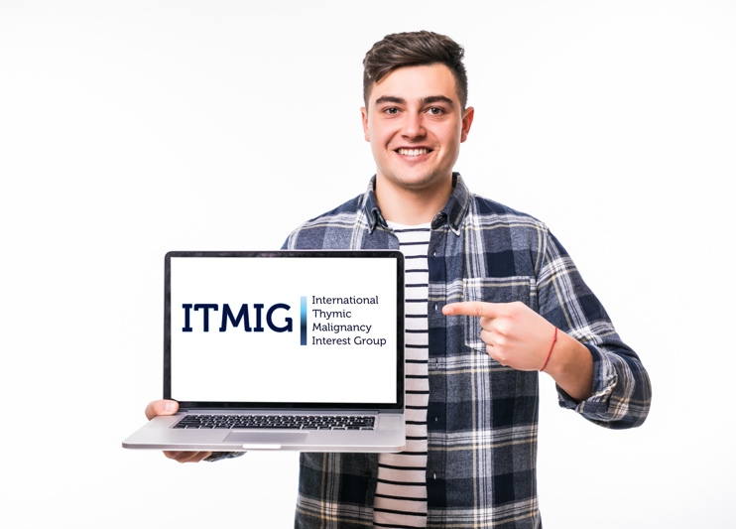](https://itmig.org)[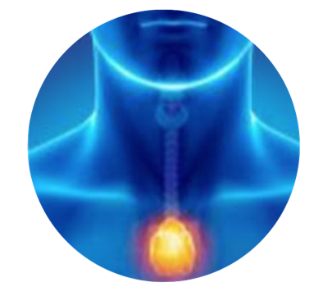](https://www.youtube.com/channel/UCZh_mzKNJ3ceF_fGc8Me5rw)

**How are thymic cancers treated?**

Your treatment will depend on the type of your diseases and its stage. The type of the disease is determined by a pathologist who analyses your tumor or its fragments under a microscope. Treatment methods include:

* **Surgery**
* **Radiation**
* **Chemotherapy**

Thymomas, thymic carcinomas and thymic neuroendocrine tumors are very rare. Not all doctors are familiar with them so your doctor may have to consult with other experts. Your case may need to be managed by a team including a thoracic surgeon, a radiation oncologist and/or medical oncologist, all working together with a radiologist and a pathologist experienced in thymic tumor diagnostics. The International Thymic Malignancy Interest Group (ITMIG) can assist in finding you a doctor that is familiar with thymic epithelial tumors.



Scan for access to ITMIG website and more information

**You are not alone!**

Need to talk with other patients?

Join the below Facebook support groups:

* [**Thymoma Support Group**](https://www.facebook.com/groups/34127563256)
* [**Thymic Carcinoma Group**](https://www.facebook.com/groups/1741748029411797)
* [**Patient Advocate Group**](https://www.facebook.com/groups/890934477969197)

or:

* [Foundation For Thymic Cancer Research](https://thymic.org)

YouTube channel

**I**[**TMIG Non-profit organization**](https://www.youtube.com/channel/UCZh_mzKNJ3ceF_fGc8Me5rw)

**The chance of recovery or recurrence depends on several factors:**

* The type of tumor
* How far the tumor has spread beyond the thymus into other tissues or organs
* Whether the tumor can be removed completely by surgery
* The patient's general health
* Whether the tumor has just been diagnosed or has recurred

Need more information?

Visit [the International Thymic Malignancy Interest Group](https://itmig.org) (ITMIG) website. ITMIG also has their own YouTube page where you can watch recordings of webinars prepared by physicians on topics of interest to thymic tumor patients and addresses patient's questions.

**MAY** **- Thymic Malignancy Awareness Month**

*This flyer was created by physicians and patients - members of ITMIG and Foundation For Thymic Cancer Research*

*Last update - 2022*